Experiment no 9- Implementing Indexing and Query Processing
Objective :
- Understand the query execution plan using EXPLAIN and EXPLAIN ANALYZE
- Comprehend how indexes improves the performance of query
  - Simple select query
  - Select query with where clause
  - Select query with order by query
  - Select query with JOIN
  - Select query with aggregation

Understanding EXPLAIN command:
This command displays the execution plan that the PostgreSQL planner generates for the supplied statement. The execution plan shows how the table(s) referenced by the statement will be scanned — by plain sequential scan, index scan, etc. — and if multiple tables are referenced, what join algorithms will be used to bring together the required rows from each input table.

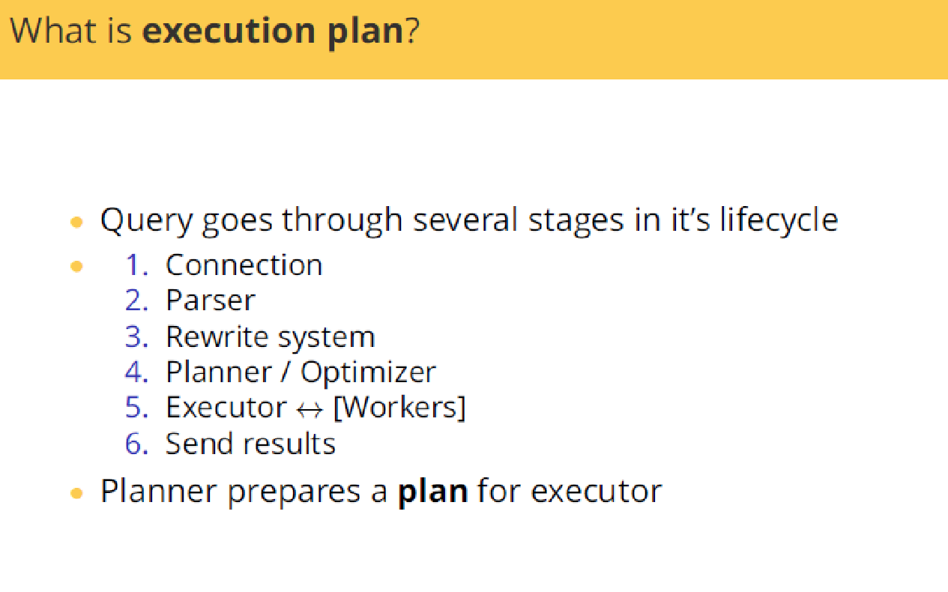
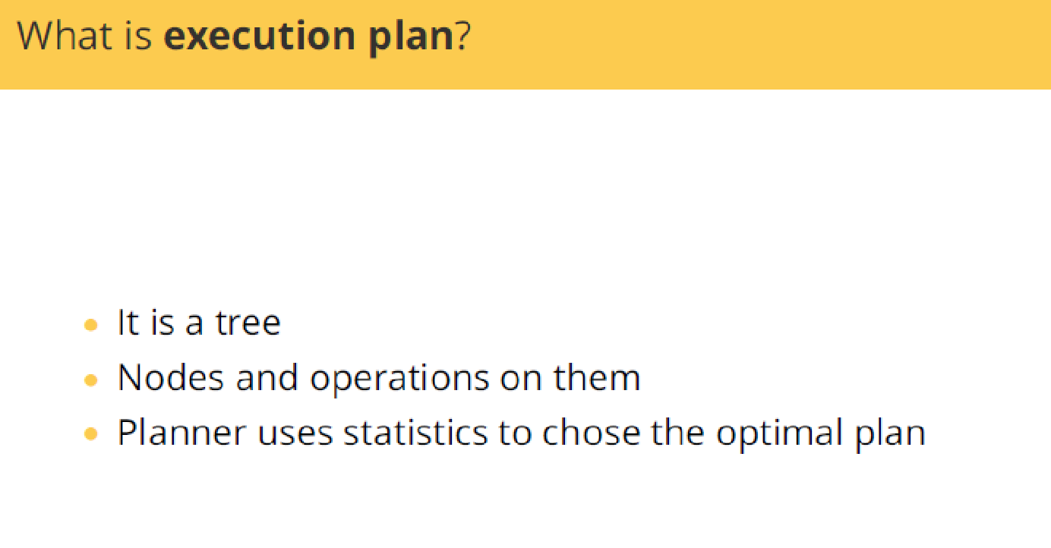
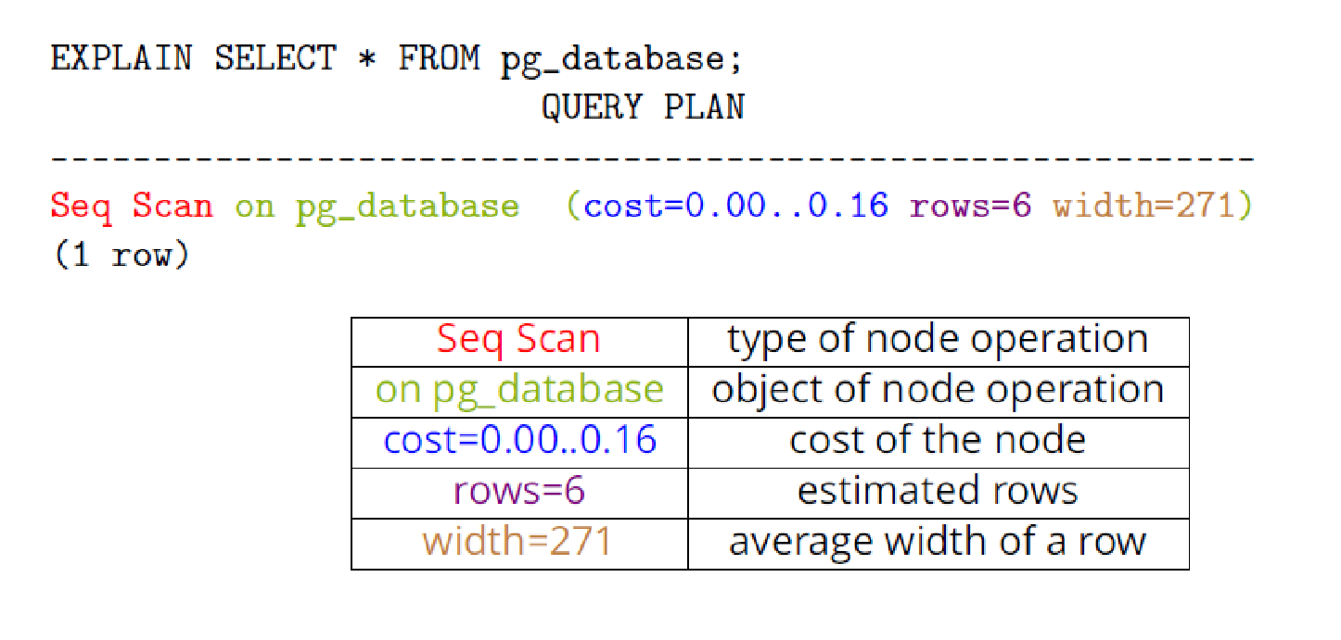

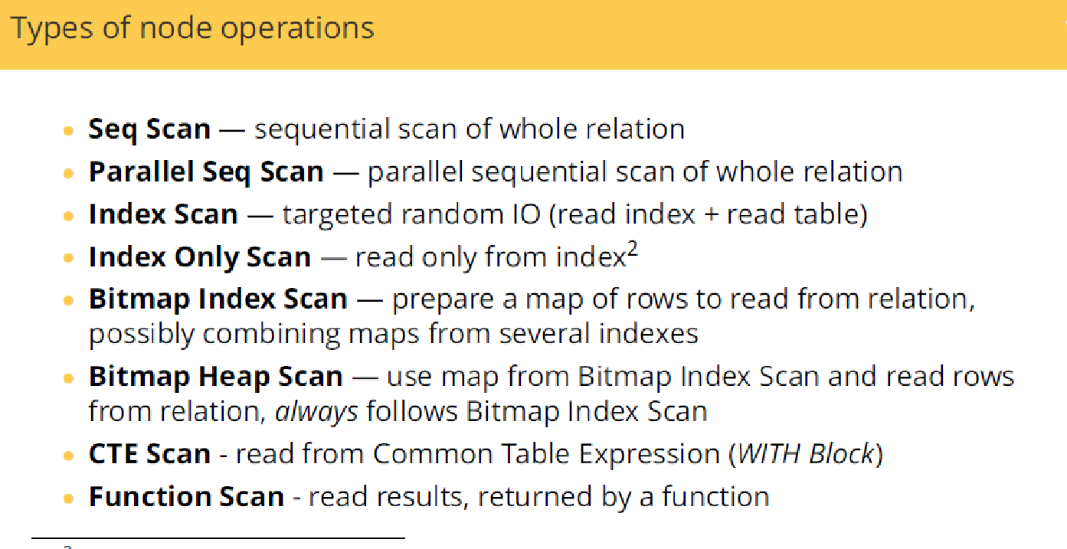
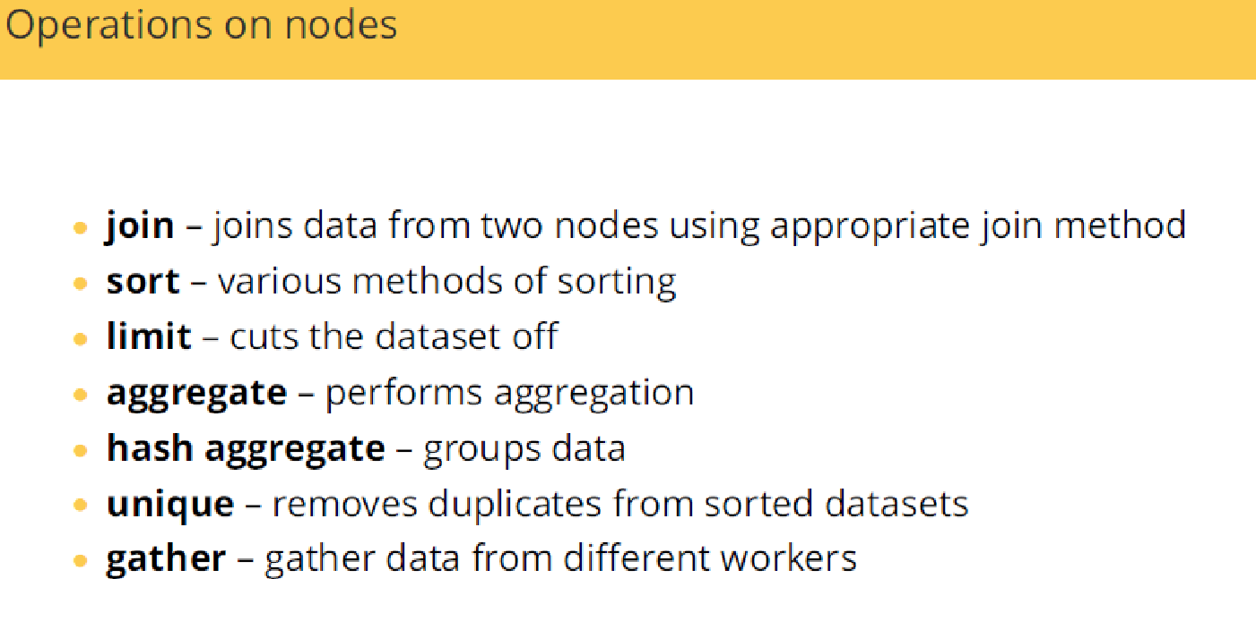
Practice:
Creating a test table with millions of rows
CREATE TABLE foo (c1 integer, c2 text);
INSERT INTO foo
SELECT i, md5(random()::text)
FROM generate_series(1, 1000000) AS i;
On trying to read the data (To show the plan for a simple query on a table having million rows)
EXPLAIN SELECT * FROM foo;
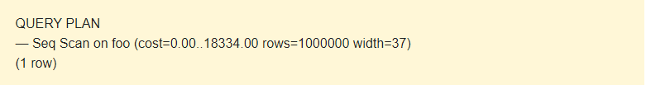
EXPLAIN notifies that a Seq Scan is used — a sequential, block-by-block, read Foo table data.
Cost: It is not the time but a concept designed to estimate the cost of an operation. The first value 0.00 is the costs for getting the first row. The second value 18334.00 is the costs for getting all the rows.
Rows are the approximate number of rows returned when a Seq Scan operation is performed. The scheduler returns this value. In this case, it matches the actual number of rows in the table.
Width is an average size of one row in bytes.
What is EXPLAIN (ANALYZE ) command ?
'EXPLAIN' shows you query cost based on collected statistics about your database, and 'EXPLAIN ANALYZE' actually runs it to show the processed time for every stage.
Lets add 10 rows
INSERT INTO foo
SELECT i, md5(random()::text)
FROM generate_series(1, 10) AS i;
EXPLAIN SELECT * FROM foo;

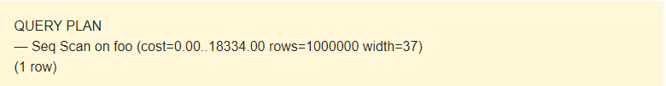
The statistics of the table is old. We need to use EXPLAIN ANALYZE to update the statistics.
EXPLAIN (ANALYZE) SELECT * FROM foo;
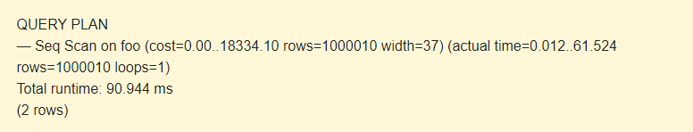
The command displays the following additional parameters:
- actual time is the actual time in milliseconds spent to get the first row and all rows, respectively.
- rows is the actual number of rows received with Seq Scan.
- loops is the number of times the Seq Scan operation had to be performed.
- Total runtime is the total time of query execution.
Query using simple WHERE condition
EXPLAIN SELECT * FROM foo WHERE c1 > 500;
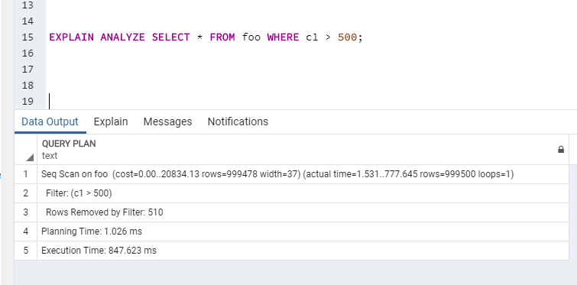
There are no indexes on the table. When executing the query, each record of the table is scanned sequentially (Seq Scan)and compared with the c1 > 500 condition. If the condition is met, the record is added to the result. Otherwise, it is discarded. Filter indicates this behavior, as well as the cost value increases.
What happens to execution time When we create index?
CREATE INDEX ON foo(c1);
EXPLAIN SELECT * FROM foo WHERE c1 > 500;
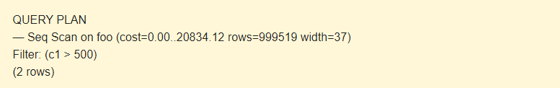
EXPLAIN (ANALYZE) SELECT * FROM foo WHERE c1 > 500;
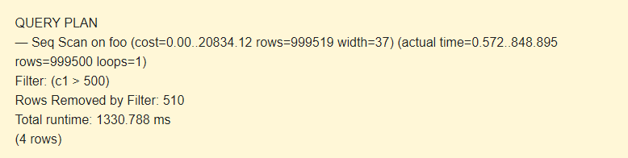
Only 510 rows of more than 1 million are filtered. PostgreSQL had to read more than 99.9 % of the table. Index is not used in the execution plan.
We will force to use the index by disabling Seq Scan:
SET enable_seqscan TO off;
EXPLAIN (ANALYZE) SELECT * FROM foo WHERE c1 > 500;
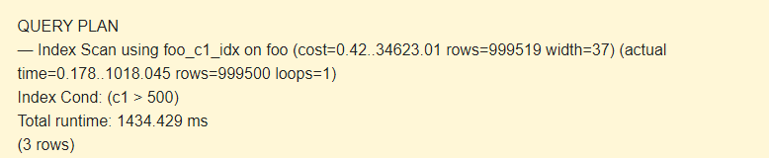
In Index Scan and Index Cond, the foo_c1_idx index is used instead of Filter.
When selecting the whole table, using the index will increase the cost and time to execute the query.
Enable Seq Scan:
SET enable_seqscan TO on;
Modify the query:
EXPLAIN SELECT * FROM foo WHERE c1 < 500;
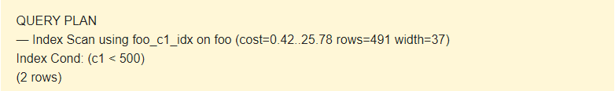
Here the planner uses the index.
Now, let’s complicate the value by adding the text field.
EXPLAIN SELECT * FROM foo
WHERE c1 < 500 AND c2 LIKE 'abcd%';
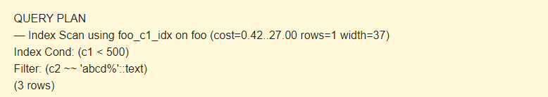
As you can see, the foo_c1_idx index is used for c1 < 500. To perform c2 ~~ ‘abcd%’::text, use the filter.
(It should be noted that the POSIX format of the LIKE operator is used in the output of the results. If there is only the text field in the condition
If you select only the field, on which the index is built, instead of the whole row:
EXPLAIN SELECT c1 FROM foo WHERE c1 < 500;
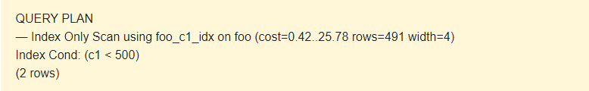
Index Only Scan will be performed faster, than Index Scan due to the fact that it is not necessary to read the row of the table: width=4.
Query using ORDER BY
DROP INDEX foo_c1_idx;
EXPLAIN (ANALYZE) SELECT * FROM foo ORDER BY c1;

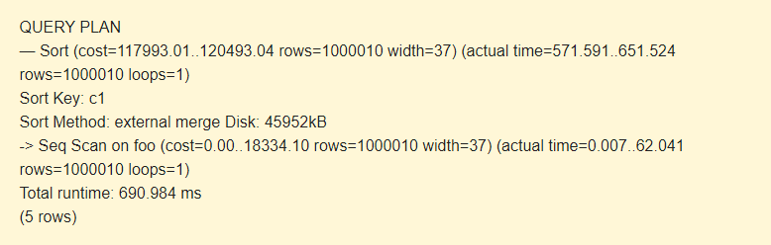
At first, you execute a sequential scan (Seq Scan) of the foo table and then, do the sorting (Sort). The -> sign of the EXPLAIN command indicates the hierarchy of steps (node). The earlier the step is executed, the greater indent it has.
Sort Key is a condition of sorting.
Sort Method: external merge Disk a temporary file on the disk with a capacity of 4592 kB is used when sorting.

CREATE INDEX ON foo(c1);
EXPLAIN (ANALYZE) SELECT * FROM foo ORDER BY c1;
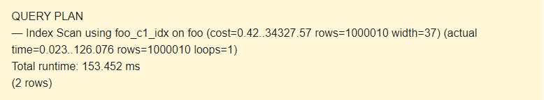
Query using JOIN
Create a new table and generate statistics for it:
CREATE TABLE bar (c1 integer, c2 boolean);
INSERT INTO bar
SELECT i, i%2=1
FROM generate_series(1, 500000) AS i;
ANALYZE bar;
The query for two tables is as follows:
EXPLAIN (ANALYZE)
SELECT * FROM foo JOIN bar ON foo.c1=bar.c1;
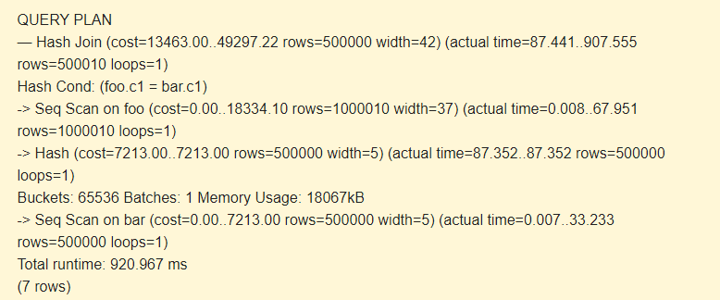

First, sequential scan (Seq Scan) reads the bar table. A hash (Hash) is calculated for each row.
Then, it scans the foo table, and for each row, a hash is calculated that is compared (Hash Join) with the hash of the bar table by the Hash Cond condition. If they match, a resulting string is outputted.
18067kB of memory is used to store hashes for the bar.
Add the index:
CREATE INDEX ON bar(c1);
EXPLAIN (ANALYZE)
SELECT * FROM foo JOIN bar ON foo.c1=bar.c1;
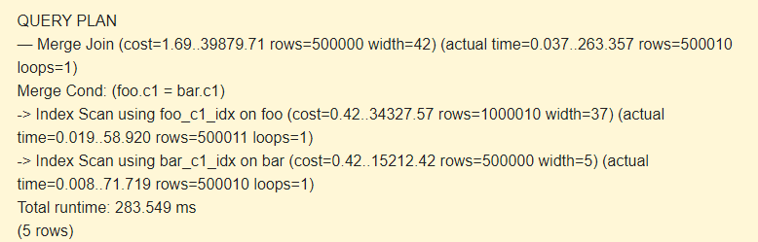
Hash is no longer used. Merge Join and Index Scan on the indices of both tables improve performance greatly.
Using Multicolumn index
Simple query without indexes
Example 2:
EXPLAIN ANALYZE SELECT line_items.product_id, SUM(line_items.price)
FROM line_items
WHERE product_id > 80
GROUP BY 1

Output of Explain Analyze
HashAggregate (cost=13.81..14.52 rows=71 width=12) (actual time=0.137..0.141 rows=20 loops=1)
Group Key: product_id
-> Seq Scan on line_items (cost=0.00..13.25 rows=112 width=8) (actual time=0.017..0.082 rows=112 loops=1)
Filter: (product_id > 80)
Rows Removed by Filter: 388
Planning time: 0.082 ms
Execution time: 0.187 ms

Adding a multicolumn index
CREATE INDEX items_product_id_price ON line_items(product_id, price)

If we create index on product_id column
CREATE INDEX items_product_id ON line_items(product_id)

As we need to sum up the price column in the query above, we still need to scan the original table. Depending on the table statistics, Postgres will choose to scan the original table instead of the index. The thing is, index lacks a 'price' column.
Now adding price into the index
CREATE INDEX items_product_id_price ON line_items(product_id, price)

Now the output of Explain analyze
GroupAggregate (cost=0.27..7.50 rows=71 width=12) (actual time=0.034..0.090 rows=20 loops=1)
Group Key: product_id
-> Index Only Scan using items_product_id_price on line_items (cost=0.27..6.23 rows=112 width=8) (actual time=0.024..0.049 rows=112 loops=1)
Index Cond: (product_id > 80)
Heap Fetches: 0
Planning time: 0.271 ms
Execution time: 0.136 ms

Execution time is reduced due to multi-column index . Order of the attribute in the index also matters.

